**Intuition**

Let's develop better intuition for how Convolutional Neural Networks (CNN) work. We'll examine how humans classify images, and then see how CNNs use similar approaches.

Let’s say we wanted to classify the following image of a dog as a Golden Retriever.

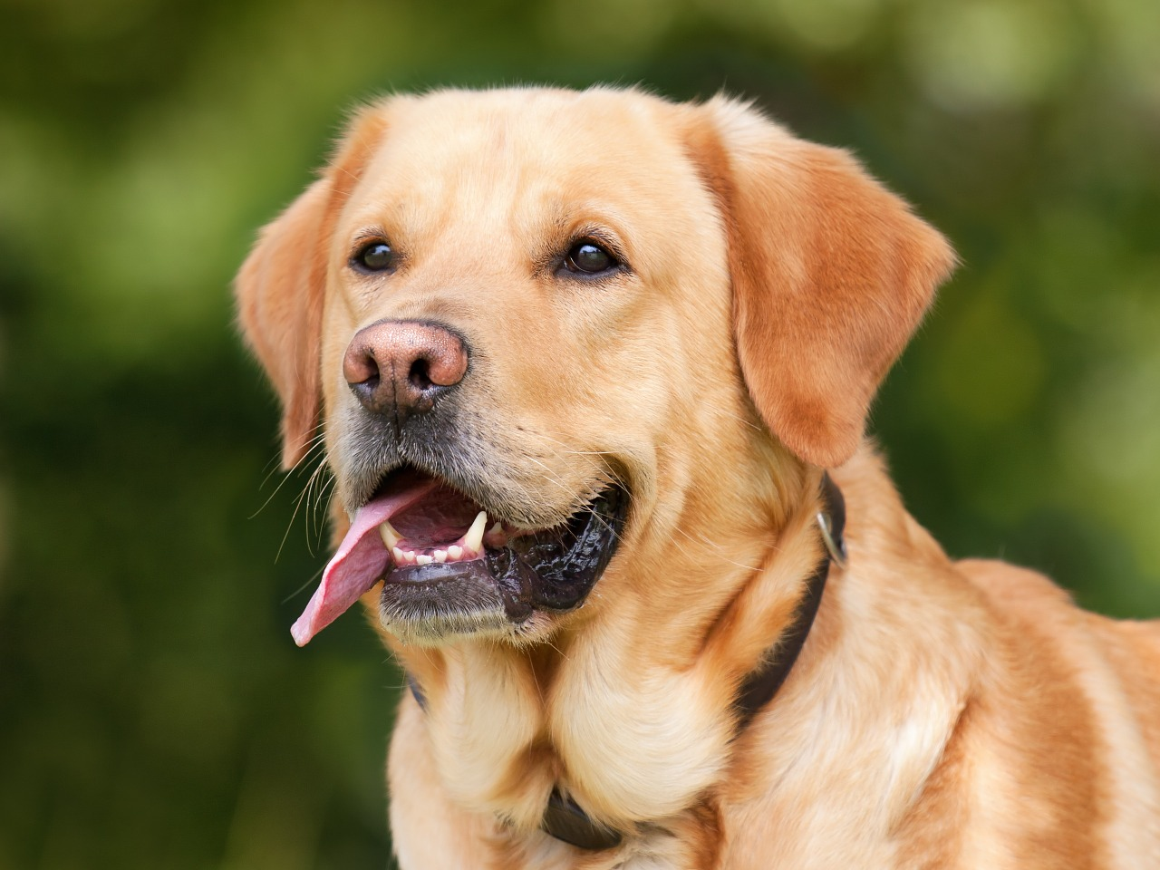

An image that we'd like to classify as a Golden Retriever.

As humans, how do we do this?

One thing we do is that we identify certain parts of the dog, such as the nose, the eyes, and the fur. We essentially break up the image into smaller pieces, recognize the smaller pieces, and then combine those pieces to get an idea of the overall dog.

In this case, we might break down the image into a combination of the following:

* A nose
* Two eyes
* Golden fur

These pieces can be seen below:

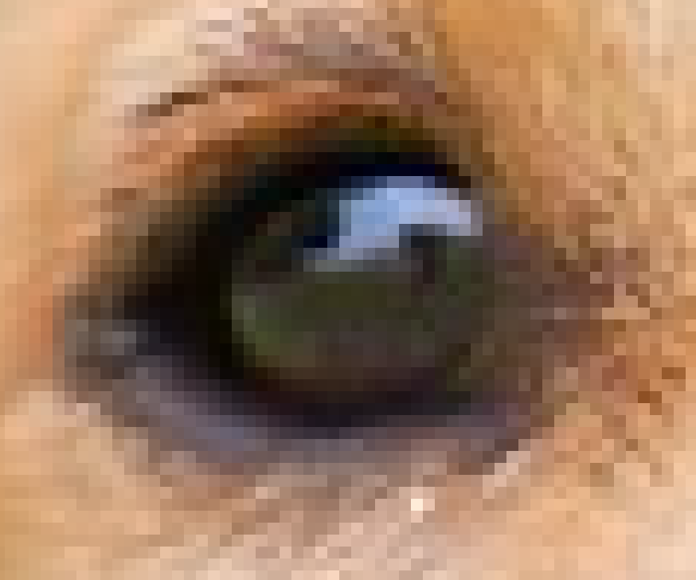

The eye of the dog.

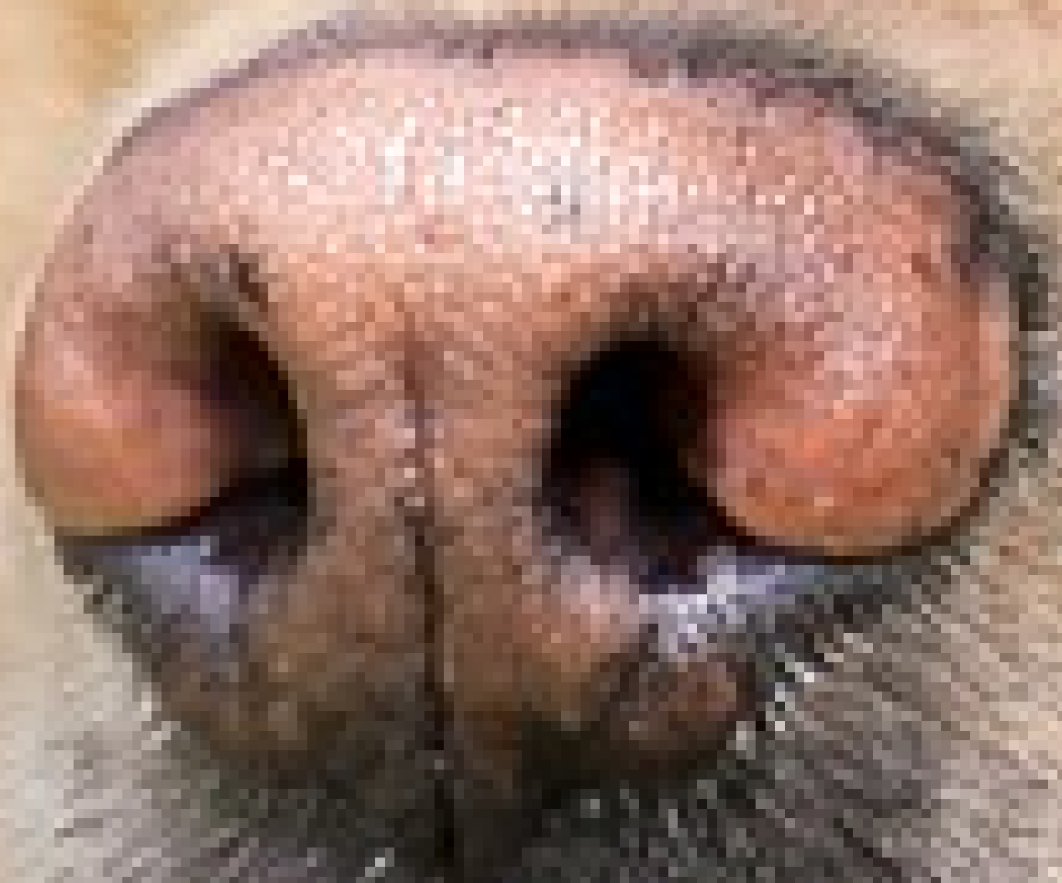

The nose of the dog.

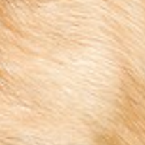

The fur of the dog.

**Going One Step Further**

But let’s take this one step further. How do we determine what exactly a nose is? A Golden Retriever nose can be seen as an oval with two black holes inside it. Thus, one way of classifying a Retriever’s nose is to to break it up into smaller pieces and look for black holes (nostrils) and curves that define an oval as shown below.

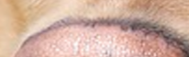

A curve that we can use to determine a nose.

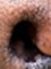

A nostril that we can use to classify a nose of the dog.

Broadly speaking, this is what a CNN learns to do. It learns to recognize basic lines and curves, then shapes and blobs, and then increasingly complex objects within the image. Finally, the CNN classifies the image by combining the larger, more complex objects.

In our case, the levels in the hierarchy are:

* Simple shapes, like ovals and dark circles
* Complex objects (combinations of simple shapes), like eyes, nose, and fur
* The dog as a whole (a combination of complex objects)

With deep learning, we don't actually program the CNN to recognize these specific features. Rather, the CNN learns on its own to recognize such objects through forward propagation and backpropagation!

It's amazing how well a CNN can learn to classify images, even though we never program the CNN with information about specific features to look for.

An example of what each layer in a CNN might recognize when classifying a picture of a dog.

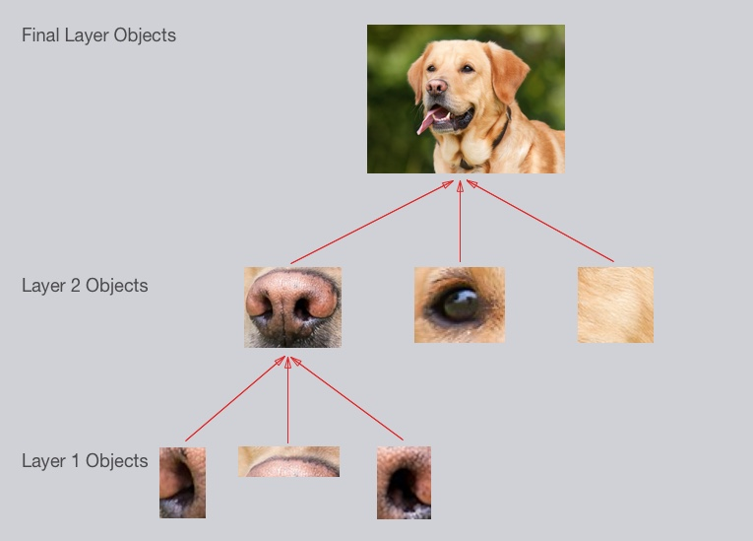

A CNN might have several layers, and each layer might capture a different level in the hierarchy of objects. The first layer is the lowest level in the hierarchy, where the CNN generally classifies small parts of the image into simple shapes like horizontal and vertical lines and simple blobs of colors. The subsequent layers tend to be higher levels in the hierarchy and generally classify more complex ideas like shapes (combinations of lines), and eventually full objects like dogs.

Once again, the CNN ***learns all of this on its own***. We don't ever have to tell the CNN to go looking for lines or curves or noses or fur. The CNN just learns from the training set and discovers which characteristics of a Golden Retriever are worth looking for.

That's a good start! Hopefully you've developed some intuition about how CNNs work.

Next, let’s look at some implementation details.

### Breaking up an Image

The first step for a CNN is to break up the image into smaller pieces. We do this by selecting a width and height that defines a filter.

The filter looks at small pieces, or patches, of the image. These patches are the same size as the filter.

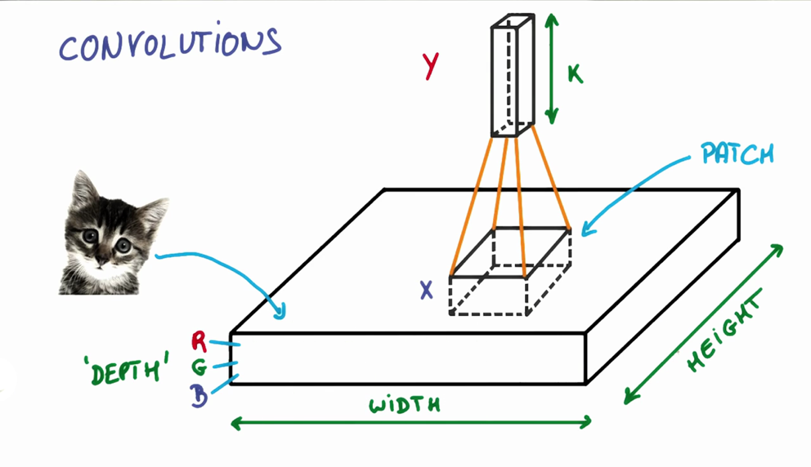

As shown in the previous video, a CNN uses filters to split an image into smaller patches. The size of these patches matches the filter size.

We then simply slide this filter horizontally or vertically to focus on a different piece of the image.

The amount by which the filter slides is referred to as the 'stride'. The stride is a hyperparameter which you, the engineer, can tune. Increasing the stride reduces the size of your model by reducing the number of total patches each layer observes. However, this usually comes with a reduction in accuracy.

Let’s look at an example. In this zoomed in image of the dog, we first start with the patch outlined in red. The width and height of our filter define the size of this square.

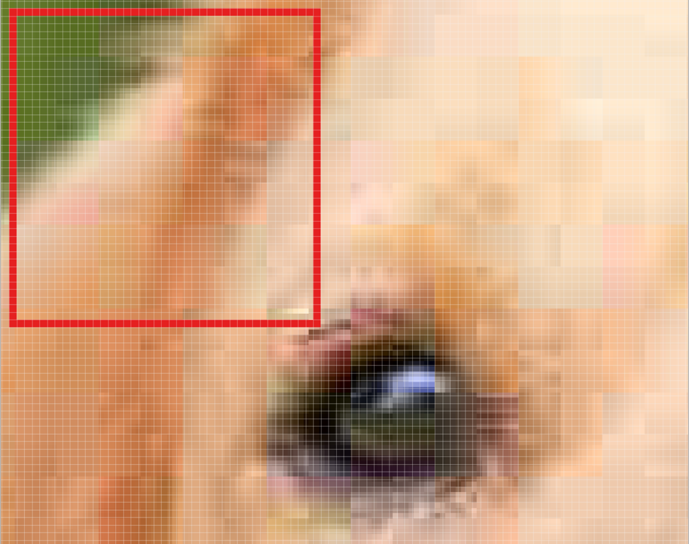

One patch of the Golden Retriever image.

We then move the square over to the right by a given stride (2 in this case) to get another patch.

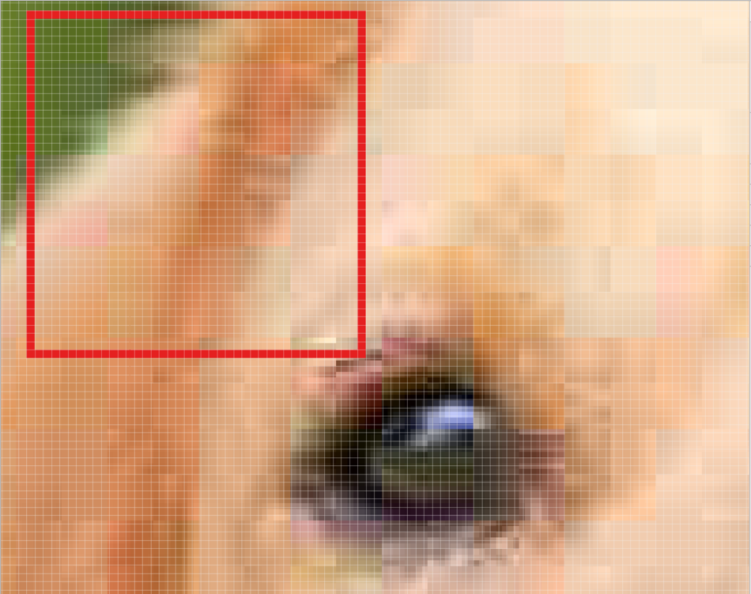

We move our square to the right by two pixels to create another patch.

What's important here is that we are **grouping together adjacent pixels** and treating them as a collective.

In a normal, non-convolutional neural network, we would have ignored this adjacency. In a normal network, we would have connected every pixel in the input image to a neuron in the next layer. In doing so, we would not have taken advantage of the fact that pixels in an image are close together for a reason and have special meaning.

By taking advantage of this local structure, our CNN learns to classify local patterns, like shapes and objects, in an image.

### Filter Depth

It's common to have more than one filter. Different filters pick up different qualities of a patch. For example, one filter might look for a particular color, while another might look for a kind of object of a specific shape. The amount of filters in a convolutional layer is called the filter depth.

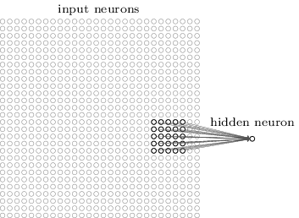

In the above example, a patch is connected to a neuron in the next layer. Source: MIchael Nielsen.

How many neurons does each patch connect to?

That’s dependent on our filter depth. If we have a depth of k, we connect each patch of pixels to k neurons in the next layer. This gives us the height of k in the next layer, as shown below. In practice, k is a hyperparameter we tune, and most CNNs tend to pick the same starting values.

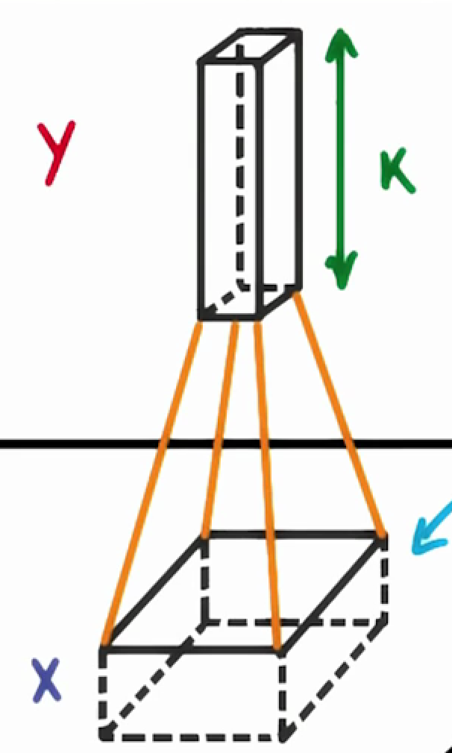

Choosing a filter depth of k connects each patch to k neurons in the next layer.

But why connect a single patch to multiple neurons in the next layer? Isn’t one neuron good enough?

Multiple neurons can be useful because a patch can have multiple interesting characteristics that we want to capture.

For example, one patch might include some white teeth, some blonde whiskers, and part of a red tongue. In that case, we might want a filter depth of at least three - one for each of teeth, whiskers, and tongue.

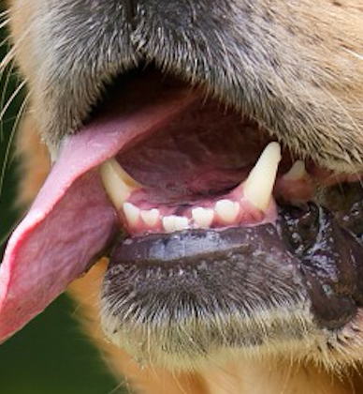

This patch of the dog has many interesting features we may want to capture. These include the presence of teeth, the presence of whiskers, and the pink color of the tongue.

Having multiple neurons for a given patch ensures that our CNN can learn to capture whatever characteristics the CNN learns are important.

Remember that the CNN isn't "programmed" to look for certain characteristics. Rather, it learns **on its own** which characteristics to notice.

Note, a "Fully Connected" layer is a standard, non convolutional layer, where all inputs are connected to all output neurons. This is also referred to as a "dense" layer, and is what we used in the previous two lessons.

### Parameter Sharing

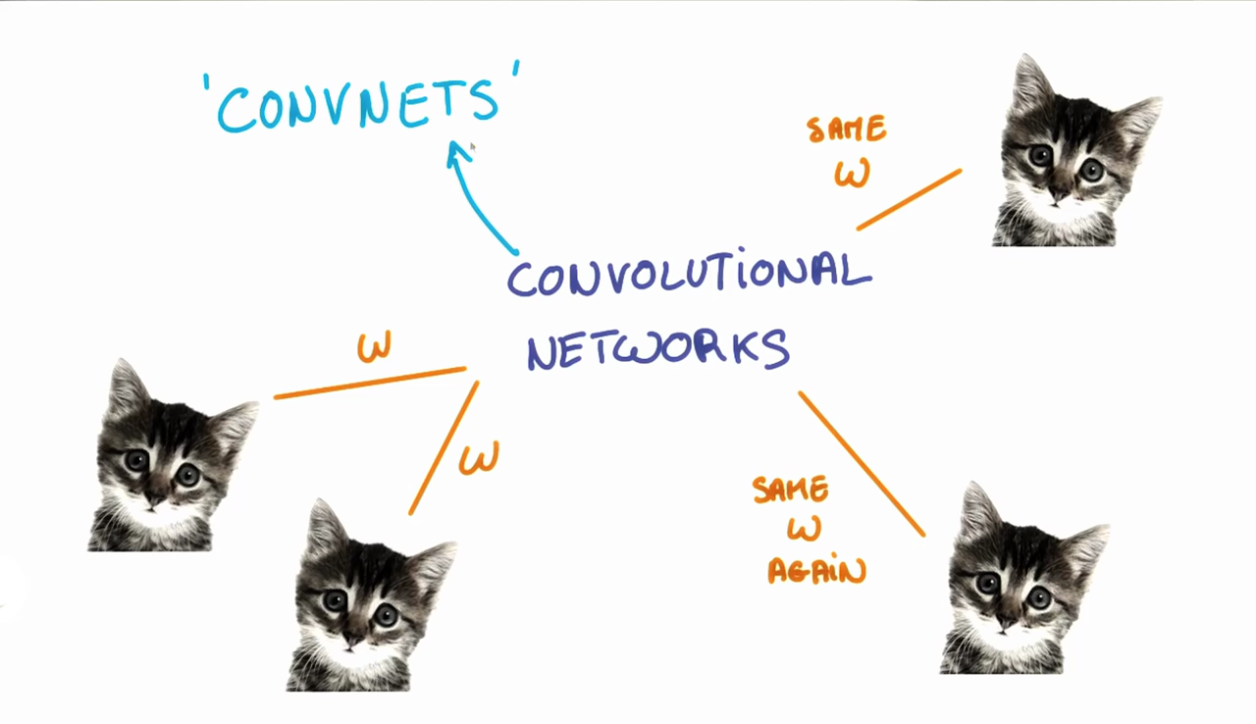

The weights, w, are shared across patches for a given layer in a CNN to detect the cat above regardless of where in the image it is located.

When we are trying to classify a picture of a cat, we don’t care where in the image a cat is. If it’s in the top left or the bottom right, it’s still a cat in our eyes. We would like our CNNs to also possess this ability known as translation invariance. How can we achieve this?

As we saw earlier, the classification of a given patch in an image is determined by the weights and biases corresponding to that patch.

If we want a cat that’s in the top left patch to be classified in the same way as a cat in the bottom right patch, we need the weights and biases corresponding to those patches to be the same, so that they are classified the same way.

This is exactly what we do in CNNs. The weights and biases we learn for a given output layer are shared across all patches in a given input layer. Note that as we increase the depth of our filter, the number of weights and biases we have to learn still increases, as the weights aren't shared across the output channels.

There’s an additional benefit to sharing our parameters. If we did not reuse the same weights across all patches, we would have to learn new parameters for every single patch and hidden layer neuron pair. This does not scale well, especially for higher fidelity images. Thus, sharing parameters not only helps us with translation invariance, but also gives us a smaller, more scalable model.

### Padding

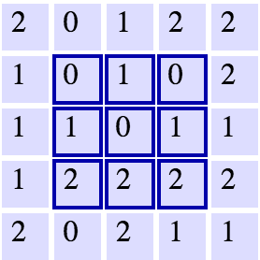

A 5x5 grid with a 3x3 filter. Source: Andrej Karpathy.

As we can see, the width and height of each subsequent layer decreases in the above scheme.

In an ideal world, we'd be able to maintain the same width and height across layers so that we can continue to add layers without worrying about the dimensionality shrinking and so that we have consistency. How might we achieve this? One way is to simply add a border of 0s to our original 5x5 image. You can see what this looks like in the below image.

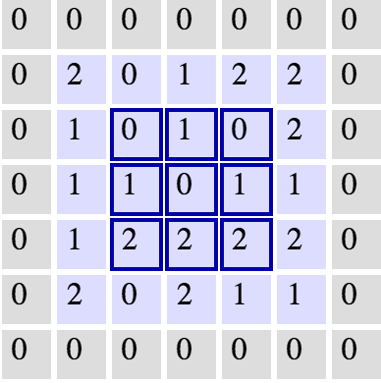

The same grid with 0 padding. Source: Andrej Karpathy.

This would expand our original image to a 7x7. With this, we now see how our next layer's size is again a 5x5, keeping our dimensionality consistent.

**Dimensionality**

From what we've learned so far, how can we calculate the number of neurons of each layer in our CNN?

Given:

* our input layer has a width of W and a height of H
* our convolutional layer has a filter size F
* we have a stride of S
* a padding of P
* and the number of filters K,

the following formula gives us the width of the next layer: W_out =[ (W−F+2P)/S] + 1.

The output height would be H_out = [(H-F+2P)/S] + 1.

And the output depth would be equal to the number of filters D_out = K.

The output volume would be W_out * H_out * D_out.

Knowing the dimensionality of each additional layer helps us understand how large our model is and how our decisions around filter size and stride affect the size of our network.

**Introduction**

For the next few quizzes we'll test your understanding of the dimensions in CNNs. Understanding dimensions will help you make accurate tradeoffs between model size and performance. As you'll see, some parameters have a much bigger impact on model size than others.

**Setup**

H = height, W = width, D = depth

* We have an input of shape 32x32x3 (HxWxD)
* 20 filters of shape 8x8x3 (HxWxD)
* A stride of 2 for both the height and width (S)
* With padding of size 1 (P)

Recall the formula for calculating the new height or width:

new_height = (input_height - filter_height + 2 * P)/S + 1

new_width = (input_width - filter_width + 2 * P)/S + 1

What's the shape of the output?

The answer format is **HxWxD**, so if you think the new height is 9, new width is 9, and new depth is 5, then type 9x9x5.

14x14x20

### Solution

The answer is **14x14x20**.

We can get the new height and width with the formula resulting in:

(32 - 8 + 2 * 1)/2 + 1 = 14

(32 - 8 + 2 * 1)/2 + 1 = 14

The new depth is equal to the number of filters, which is 20.

This would correspond to the following code:

input = tf.placeholder(tf.float32, (**None**, 32, 32, 3))

filter_weights = tf.Variable(tf.truncated_normal((8, 8, 3, 20))) *# (height, width, input_depth, output_depth)*

filter_bias = tf.Variable(tf.zeros(20))

strides = [1, 2, 2, 1] *# (batch, height, width, depth)*

padding = 'SAME'

conv = tf.nn.conv2d(input, filter_weights, strides, padding) + filter_bias

Note the output shape of conv will be [1, 16, 16, 20]. It's 4D to account for batch size, but more importantly, it's not [1, 14, 14, 20]. This is because the padding algorithm TensorFlow uses is not exactly the same as the one above. An alternative algorithm is to switch padding from 'SAME' to 'VALID' which would result in an output shape of [1, 13, 13, 20]. If you're curious how padding works in TensorFlow, read [this document](https://www.tensorflow.org/api_docs/python/tf/nn/convolution).

In summary TensorFlow uses the following equation for 'SAME' vs 'VALID'

**SAME Padding**, the output height and width are computed as:

out_height = ceil(float(in_height) / float(strides[1]))

out_width = ceil(float(in_width) / float(strides[2]))

**VALID Padding**, the output height and width are computed as:

out_height = ceil(float(in_height - filter_height + 1) / float(strides[1]))

out_width = ceil(float(in_width - filter_width + 1) / float(strides[2]))

We're now going to calculate the number of parameters of the convolutional layer. The answer from the last quiz will come into play here!

Being able to calculate the number of parameters in a neural network is useful since we want to have control over how much memory a neural network uses.

### Setup

H = height, W = width, D = depth

* We have an input of shape 32x32x3 (HxWxD)
* 20 filters of shape 8x8x3 (HxWxD)
* A stride of 2 for both the height and width (S)
* Zero padding of size 1 (P)

### Output Layer

* 14x14x20 (HxWxD)

### Hint

Without parameter sharing, each neuron in the output layer must connect to each neuron in the filter. In addition, each neuron in the output layer must also connect to a single bias neuron.

### Solution

There are 756560 total parameters. That's a HUGE amount! Here's how we calculate it:

(8 * 8 * 3 + 1) * (14 * 14 * 20) = 756560

8 * 8 * 3 is the number of weights, we add 1 for the bias. Remember, each weight is assigned to every single part of the output (14 * 14 * 20). So we multiply these two numbers together and we get the final answer.

Now we'd like you to calculate the number of parameters in the convolutional layer, if every neuron in the output layer shares its parameters with every other neuron in its same channel.

This is the number of parameters actually used in a convolution layer ([tf.nn.conv2d()](https://www.tensorflow.org/api_docs/python/tf/nn/conv2d)).

### Setup

H = height, W = width, D = depth

* We have an input of shape 32x32x3 (HxWxD)
* 20 filters of shape 8x8x3 (HxWxD)
* A stride of 2 for both the height and width (S)
* Zero padding of size 1 (P)

### Output Layer

* 14x14x20 (HxWxD)

### Hint

With parameter sharing, each neuron in an output channel shares its weights with every other neuron in that channel. So the number of parameters is equal to the number of neurons in the filter, plus a bias neuron, all multiplied by the number of channels in the output layer.

### Solution

There are 3860 total parameters. That's 196 times fewer parameters! Here's how the answer is calculated:

(8 * 8 * 3 + 1) * 20 = 3840 + 20 = 3860

That's 3840 weights and 20 biases. This should look similar to the answer from the previous quiz. The difference being it's just 20 instead of (14 * 14 * 20). Remember, with weight sharing we use the same filter for an entire depth slice. Because of this we can get rid of 14 * 14 and be left with only 20.

**Visualizing CNNs**

Let’s look at an example CNN to see how it works in action.

The CNN we will look at is trained on ImageNet as described in [this paper](https://arxiv.org/abs/1311.2901) by Zeiler and Fergus. In the images below (from the same paper), we’ll see *what* each layer in this network detects and see *how* each layer detects more and more complex ideas.

**Layer 1**

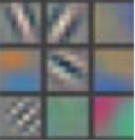

Example patterns that cause activations in the first layer of the network. These range from simple diagonal lines (top left) to green blobs (bottom middle).

The images above are from Matthew Zeiler and Rob Fergus' [deep visualization toolbox](https://www.youtube.com/watch?v=ghEmQSxT6tw), which lets us visualize what each layer in a CNN focuses on.

Each image in the above grid represents a pattern that causes the neurons in the first layer to activate - in other words, they are patterns that the first layer recognizes. The top left image shows a -45 degree line, while the middle top square shows a +45 degree line. These squares are shown below again for reference.

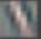

As visualized here, the first layer of the CNN can recognize -45 degree lines.

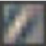

The first layer of the CNN is also able to recognize +45 degree lines, like the one above.

Let's now see some example images that cause such activations. The below grid of images all activated the -45 degree line. Notice how they are all selected despite the fact that they have different colors, gradients, and patterns.

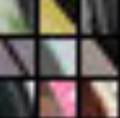

Example patches that activate the -45 degree line detector in the first layer.

So, the first layer of our CNN clearly picks out very simple shapes and patterns like lines and blobs.

**Layer 2**

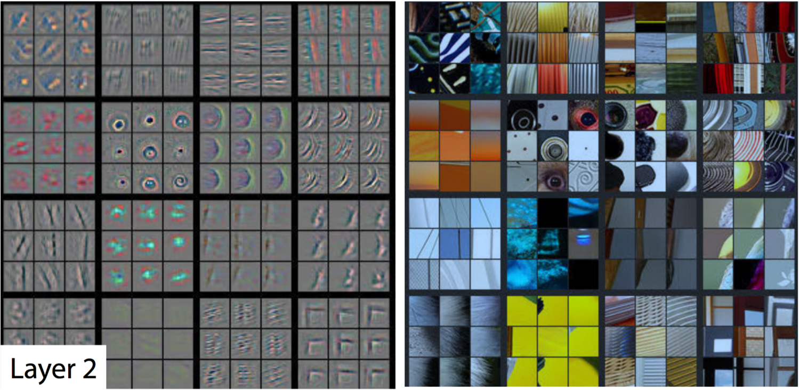

A visualization of the second layer in the CNN. Notice how we are picking up more complex ideas like circles and stripes. The gray grid on the left represents how this layer of the CNN activates (or "what it sees") based on the corresponding images from the grid on the right.

The second layer of the CNN captures complex ideas.

As you see in the image above, the second layer of the CNN recognizes circles (second row, second column), stripes (first row, second column), and rectangles (bottom right).

**The CNN learns to do this on its own.** There is no special instruction for the CNN to focus on more complex objects in deeper layers. That's just how it normally works out when you feed training data into a CNN.

**Layer 3**

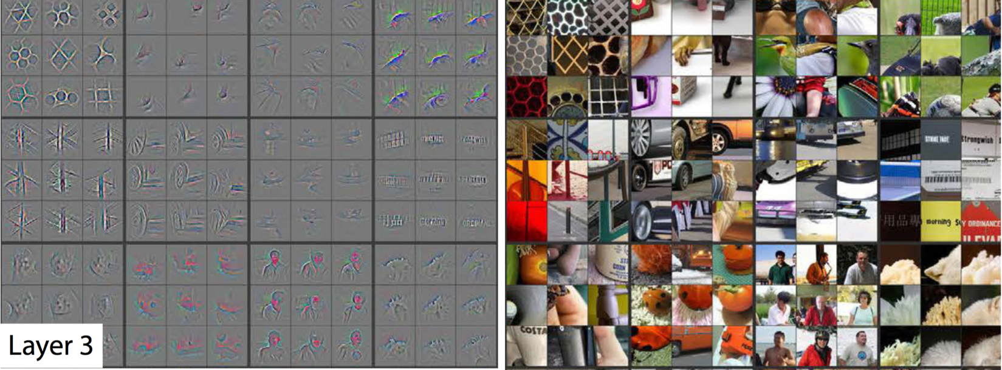

A visualization of the third layer in the CNN. The gray grid on the left represents how this layer of the CNN activates (or "what it sees") based on the corresponding images from the grid on the right.

The third layer picks out complex combinations of features from the second layer. These include things like grids, and honeycombs (top left), wheels (second row, second column), and even faces (third row, third column).

We'll skip layer 4, which continues this progression, and jump right to the fifth and final layer of this CNN.

**Layer 5**

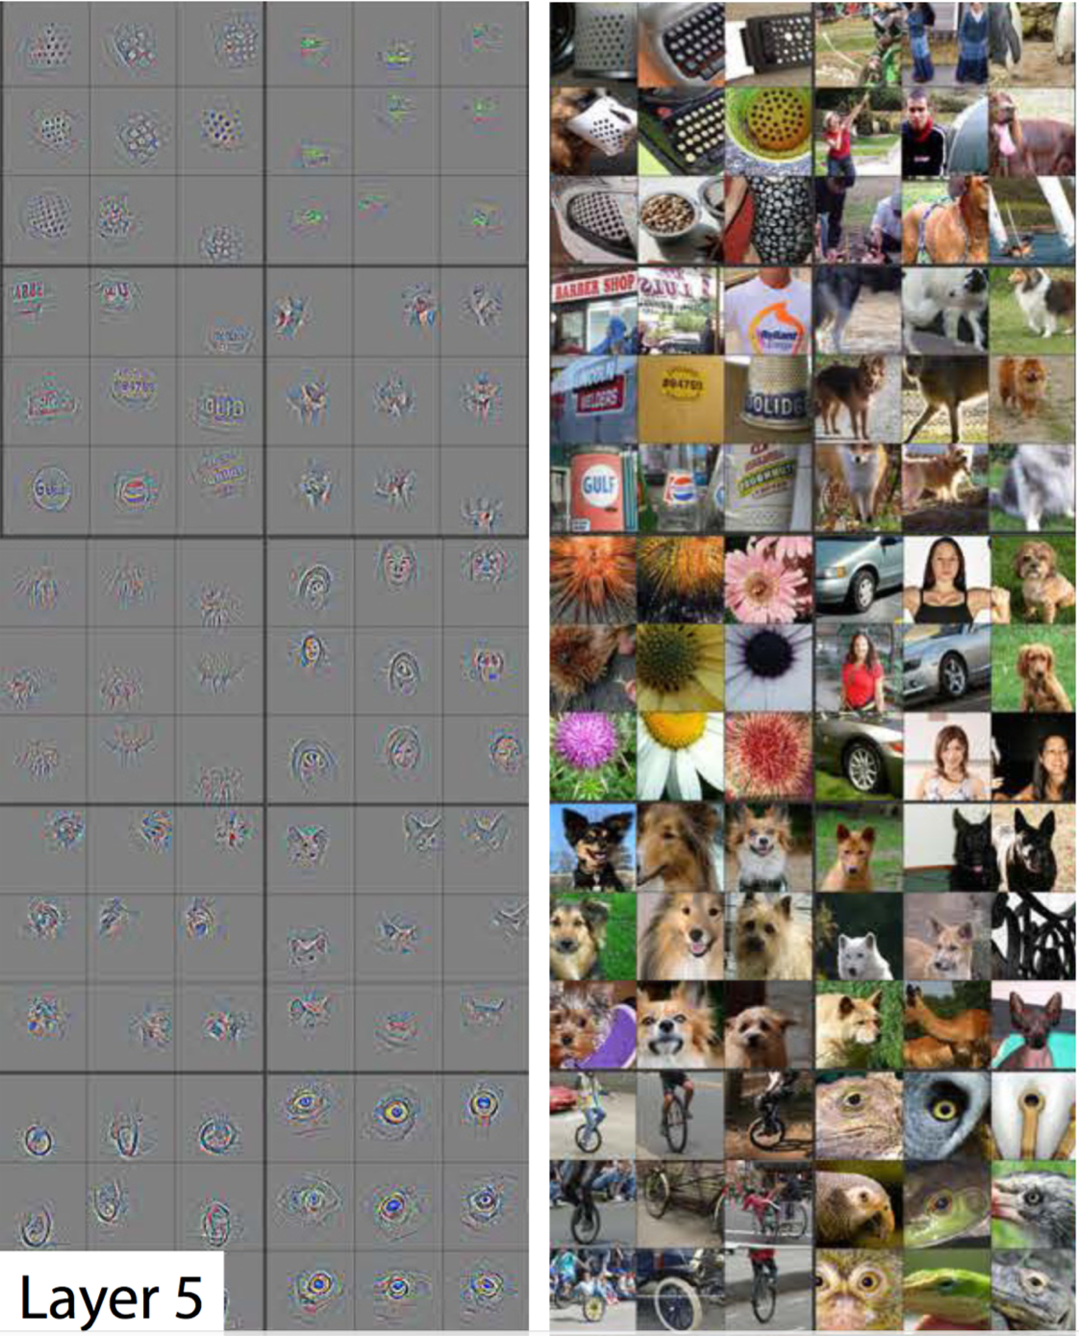

A visualization of the fifth and final layer of the CNN. The gray grid on the left represents how this layer of the CNN activates (or "what it sees") based on the corresponding images from the grid on the right.

The last layer picks out the highest order ideas that we care about for classification, like dog faces, bird faces, and bicycles.

**On to TensorFlow**

This concludes our high-level discussion of Convolutional Neural Networks.

Next you'll practice actually building these networks in TensorFlow.

### TensorFlow Convolution Layer

Let's examine how to implement a CNN in TensorFlow.

TensorFlow provides the [tf.nn.conv2d()](https://www.tensorflow.org/api_docs/python/tf/nn/conv2d) and [tf.nn.bias_add()](https://www.tensorflow.org/api_docs/python/tf/nn/bias_add) functions to create your own convolutional layers.

*# Output depth*

k_output = 64

*# Image Properties*

image_width = 10

image_height = 10

color_channels = 3

*# Convolution filter*

filter_size_width = 5

filter_size_height = 5

*# Input/Image*

input = tf.placeholder(

tf.float32,

shape=[**None**, image_height, image_width, color_channels])

*# Weight and bias*

weight = tf.Variable(tf.truncated_normal(

[filter_size_height, filter_size_width, color_channels, k_output]))

bias = tf.Variable(tf.zeros(k_output))

*# Apply Convolution*

conv_layer = tf.nn.conv2d(input, weight, strides=[1, 2, 2, 1], padding='SAME')

*# Add bias*

conv_layer = tf.nn.bias_add(conv_layer, bias)

*# Apply activation function*

conv_layer = tf.nn.relu(conv_layer)

The code above uses the [tf.nn.conv2d()](https://www.tensorflow.org/api_docs/python/tf/nn/conv2d) function to compute the convolution with weight as the filter and [1, 2, 2, 1] for the strides. TensorFlow uses a stride for each input dimension, [batch, input_height, input_width, input_channels]. We are generally always going to set the stride for batch and input_channels (i.e. the first and fourth element in the strides array) to be 1.

You'll focus on changing input_height and input_width while setting batch and input_channels to 1. The input_height and input_width strides are for striding the filter over input. This example code uses a stride of 2 with 5x5 filter over input.

The [tf.nn.bias_add()](https://www.tensorflow.org/api_docs/python/tf/nn/bias_add) function adds a 1-d bias to the last dimension in a matrix.

# TensorFlow Max Pooling



By Aphex34 (Own work) [CC BY-SA 4.0 ([http://creativecommons.org/licenses/by-sa/4.0)]](http://creativecommons.org/licenses/by-sa/4.0)%5d), via Wikimedia Commons

The image above is an example of [max pooling](https://en.wikipedia.org/wiki/Convolutional_neural_network#Pooling_layer) with a 2x2 filter and stride of 2. The four 2x2 colors represent each time the filter was applied to find the maximum value.

For example, [[1, 0], [4, 6]] becomes 6, because 6 is the maximum value in this set. Similarly, [[2, 3], [6, 8]] becomes 8.

Conceptually, the benefit of the max pooling operation is to reduce the size of the input, and allow the neural network to focus on only the most important elements. Max pooling does this by only retaining the maximum value for each filtered area, and removing the remaining values.

TensorFlow provides the [tf.nn.max_pool()](https://www.tensorflow.org/api_docs/python/tf/nn/max_pool) function to apply [max pooling](https://en.wikipedia.org/wiki/Convolutional_neural_network#Pooling_layer) to your convolutional layers.

...

conv_layer = tf.nn.conv2d(input, weight, strides=[1, 2, 2, 1], padding='SAME')

conv_layer = tf.nn.bias_add(conv_layer, bias)

conv_layer = tf.nn.relu(conv_layer)

*# Apply Max Pooling*

conv_layer = tf.nn.max_pool(

conv_layer,

ksize=[1, 2, 2, 1],

strides=[1, 2, 2, 1],

padding='SAME')

The [tf.nn.max_pool()](https://www.tensorflow.org/api_docs/python/tf/nn/max_pool) function performs max pooling with the ksize parameter as the size of the filter and the strides parameter as the length of the stride. 2x2 filters with a stride of 2x2 are common in practice.

The ksize and strides parameters are structured as 4-element lists, with each element corresponding to a dimension of the input tensor ([batch, height, width, channels]). For both ksize and strides, the batch and channel dimensions are typically set to 1.

The next few quizzes will test your understanding of **pooling layers**.

### QUIZ QUESTION

A pooling layer is generally used to ...

* Decrease the size of the output
* Prevent overfitting

### Solution

The correct answer is **decrease the size of the output** and **prevent overfitting**. Preventing overfitting is a consequence of reducing the output size, which in turn, reduces the number of parameters in future layers.

Recently, pooling layers have fallen out of favor. Some reasons are:

* Recent datasets are so big and complex we're more concerned about underfitting.
* Dropout is a much better regularizer.
* Pooling results in a loss of information. Think about the max pooling operation as an example. We only keep the largest of n numbers, thereby disregarding n-1 numbers completely.

### Setup

H = height, W = width, D = depth

* We have an input of shape 4x4x5 (HxWxD)
* Filter of shape 2x2 (HxW)
* A stride of 2 for both the height and width (S)

Recall the formula for calculating the new height or width:

new_height = (input_height - filter_height)/S + 1

new_width = (input_width - filter_width)/S + 1

NOTE: For a pooling layer the output depth is the same as the input depth. Additionally, the pooling operation is applied individually for each depth slice.

The image below gives an example of how a max pooling layer works. In this case, the max pooling filter has a shape of 2x2. As the max pooling filter slides across the input layer, the filter will output the maximum value of the 2x2 square.

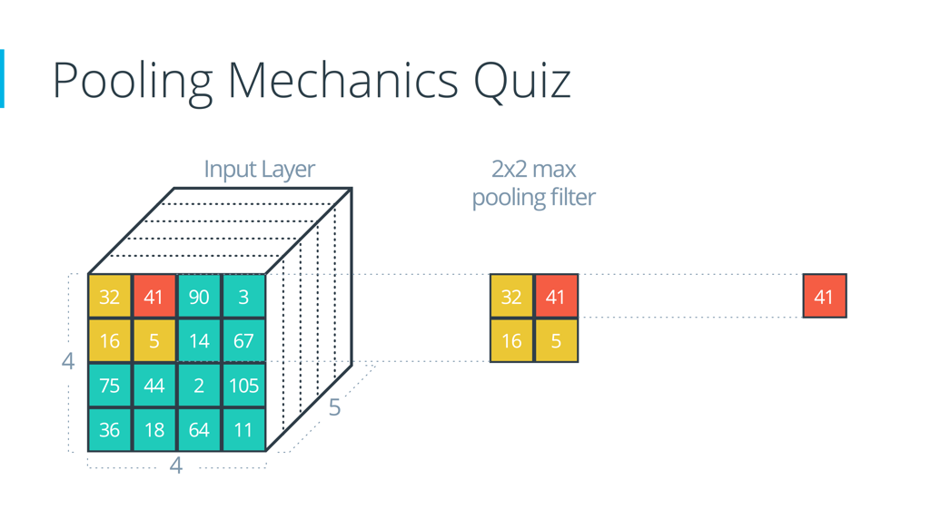

### Solution

The answer is **2x2x5**. Here's how it's calculated using the formula:

(4 - 2)/2 + 1 = 2

(4 - 2)/2 + 1 = 2

The depth stays the same.

Here's the corresponding code:

input = tf.placeholder(tf.float32, (**None**, 4, 4, 5))

filter_shape = [1, 2, 2, 1]

strides = [1, 2, 2, 1]

padding = 'VALID'

pool = tf.nn.max_pool(input, filter_shape, strides, padding)

The output shape of pool will be [1, 2, 2, 5], even if padding is changed to 'SAME'.

**Great, now let's practice doing some pooling operations manually.**

## Max Pooling

What's the result of a **max pooling** operation on the input:

[[[0, 1, 0.5, 10],

[2, 2.5, 1, -8],

[4, 0, 5, 6],

[15, 1, 2, 3]]]

Assume the filter is 2x2 and the stride is 2 for both height and width. The output shape is 2x2x1.

The answering format will be 4 numbers, each separated by a comma, such as: 1,2,3,4.

**Work from the top left to the bottom right**

2.5, 10, 15, 6

### Solution

The correct answer is 2.5,10,15,6. We start with the four numbers in the top left corner. Then we work left-to-right and top-to-bottom, moving 2 units each time.

max(0, 1, 2, 2.5) = 2.5

max(0.5, 10, 1, -8) = 10

max(4, 0, 15, 1) = 15

max(5, 6, 2, 3) = 6

## Mean Pooling

What's the result of a **average (or mean) pooling**?

[[[0, 1, 0.5, 10],

[2, 2.5, 1, -8],

[4, 0, 5, 6],

[15, 1, 2, 3]]]

Assume the filter is 2x2 and the stride is 2 for both height and width. The output shape is 2x2x1.

The answering format will be 4 numbers, each separated by a comma, such as: 1,2,3,4.

**Answer to 3 decimal places. Work from the top left to the bottom right**

### Solution

The correct answer is 1.375,0.875,5,4. We start with the four numbers in the top left corner. Then we work left-to-right and top-to-bottom, moving 2 units each time.

mean(0, 1, 2, 2.5) = 1.375

mean(0.5, 10, 1, -8) = 0.875

mean(4, 0, 15, 1) = 5

mean(5, 6, 2, 3) = 4

# Convolutional Network in TensorFlow

It's time to walk through an example Convolutional Neural Network (CNN) in TensorFlow.

The structure of this network follows the classic structure of CNNs, which is a mix of convolutional layers and max pooling, followed by fully-connected layers.

The code you'll be looking at is similar to what you saw in the segment on **Deep Neural Network in TensorFlow** in the previous lesson, except we restructured the architecture of this network as a CNN.

Just like in that segment, here you'll study the line-by-line breakdown of the code. If you want, you can even [download the code](https://d17h27t6h515a5.cloudfront.net/topher/2017/February/58a61ca1_cnn/cnn.zip) and run it yourself.

Thanks to [Aymeric Damien](https://github.com/aymericdamien/TensorFlow-Examples) for providing the original TensorFlow model on which this segment is based.

Time to dive in!

### Dataset

You've seen this section of code from previous lessons. Here we're importing the MNIST dataset and using a convenient TensorFlow function to batch, scale, and One-Hot encode the data.

**from** tensorflow.examples.tutorials.mnist **import** input_data

mnist = input_data.read_data_sets(".", one_hot=**True**, reshape=**False**)

**import** tensorflow **as** tf

*# Parameters*

learning_rate = 0.00001

epochs = 10

batch_size = 128

*# Number of samples to calculate validation and accuracy*

*# Decrease this if you're running out of memory to calculate accuracy*

test_valid_size = 256

*# Network Parameters*

n_classes = 10 *# MNIST total classes (0-9 digits)*

dropout = 0.75 *# Dropout, probability to keep units*

### Weights and Biases

*# Store layers weight & bias*

weights = {

'wc1': tf.Variable(tf.random_normal([5, 5, 1, 32])),

'wc2': tf.Variable(tf.random_normal([5, 5, 32, 64])),

'wd1': tf.Variable(tf.random_normal([7*7*64, 1024])),

'out': tf.Variable(tf.random_normal([1024, n_classes]))}

biases = {

'bc1': tf.Variable(tf.random_normal([32])),

'bc2': tf.Variable(tf.random_normal([64])),

'bd1': tf.Variable(tf.random_normal([1024])),

'out': tf.Variable(tf.random_normal([n_classes]))}

### Convolutions



Convolution with 3×3 Filter. Source: <http://deeplearning.stanford.edu/wiki/index.php/Feature_extraction_using_convolution>

The above is an example of a [convolution](https://en.wikipedia.org/wiki/Convolution) with a 3x3 filter and a stride of 1 being applied to data with a range of 0 to 1. The convolution for each 3x3 section is calculated against the weight, [[1, 0, 1], [0, 1, 0], [1, 0, 1]], then a bias is added to create the convolved feature on the right. In this case, the bias is zero. In TensorFlow, this is all done using [tf.nn.conv2d()](https://www.tensorflow.org/api_docs/python/tf/nn/conv2d) and [tf.nn.bias_add()](https://www.tensorflow.org/api_docs/python/tf/nn/bias_add).

**def** **conv2d**(x, W, b, strides=1):

x = tf.nn.conv2d(x, W, strides=[1, strides, strides, 1], padding='SAME')

x = tf.nn.bias_add(x, b)

**return** tf.nn.relu(x)

The [tf.nn.conv2d()](https://www.tensorflow.org/api_docs/python/tf/nn/conv2d) function computes the convolution against weight W as shown above.

In TensorFlow, strides is an array of 4 elements; the first element in this array indicates the stride for batch and last element indicates stride for features. It's good practice to remove the batches or features you want to skip from the data set rather than use a stride to skip them. You can always set the first and last element to 1 in strides in order to use all batches and features.

The middle two elements are the strides for height and width respectively. I've mentioned stride as one number because you usually have a square stride where height = width. When someone says they are using a stride of 3, they usually mean tf.nn.conv2d(x, W, strides=[1, 3, 3, 1]).

To make life easier, the code is using [tf.nn.bias_add()](https://www.tensorflow.org/api_docs/python/tf/nn/bias_add) to add the bias. Using [tf.add()](https://www.tensorflow.org/api_docs/python/tf/add) doesn't work when the tensors aren't the same shape.

### Max Pooling

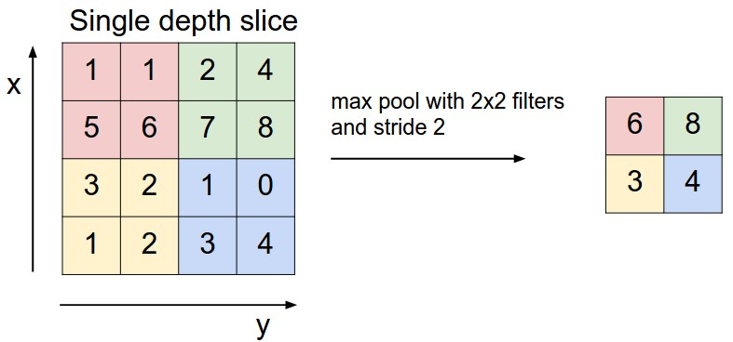

Max Pooling with 2x2 filter and stride of 2. Source: <http://cs231n.github.io/convolutional-networks/>

The above is an example of [max pooling](https://en.wikipedia.org/wiki/Convolutional_neural_network#Pooling_layer) with a 2x2 filter and stride of 2. The left square is the input and the right square is the output. The four 2x2 colors in input represents each time the filter was applied to create the max on the right side. For example, [[1, 1], [5, 6]] becomes 6 and [[3, 2], [1, 2]] becomes 3.

**def** **maxpool2d**(x, k=2):

**return** tf.nn.max_pool(

x,

ksize=[1, k, k, 1],

strides=[1, k, k, 1],

padding='SAME')

The [tf.nn.max_pool()](https://www.tensorflow.org/api_docs/python/tf/nn/max_pool) function does exactly what you would expect, it performs max pooling with the ksize parameter as the size of the filter.

### Model

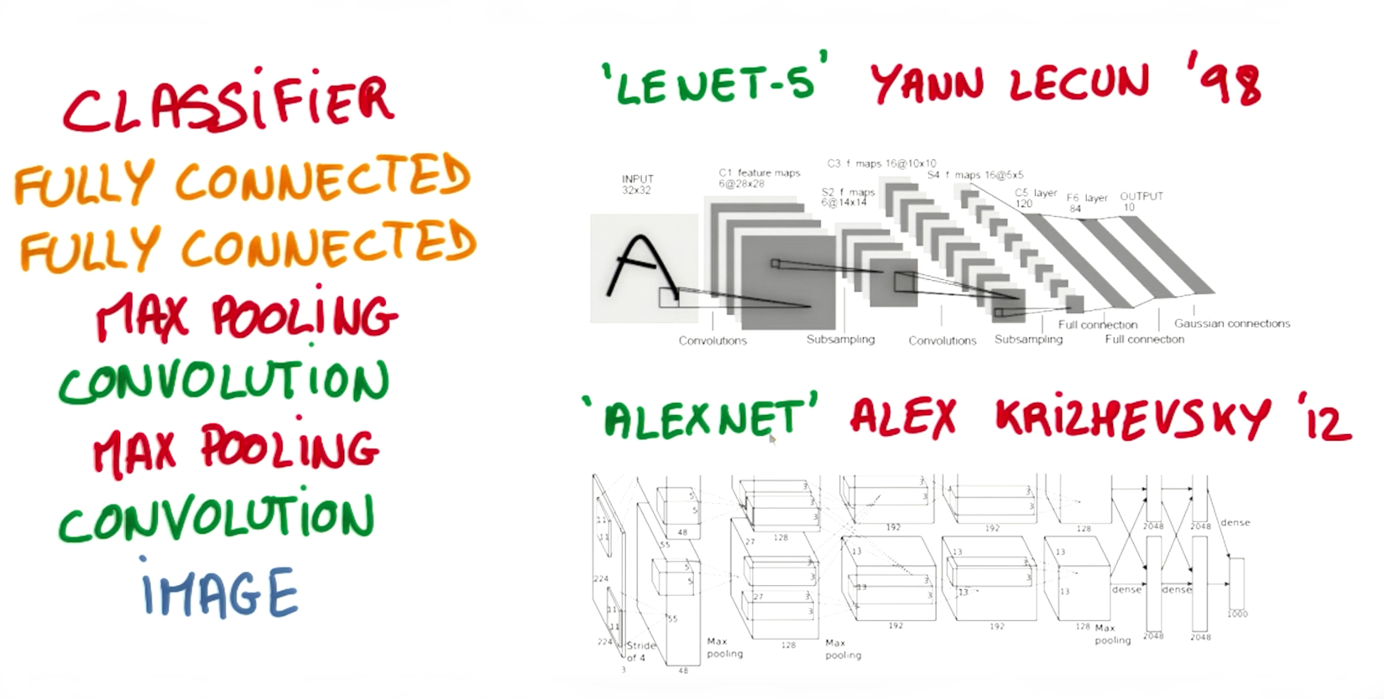

Image from Explore The Design Space video

In the code below, we're creating 3 layers alternating between convolutions and max pooling followed by a fully connected and output layer. The transformation of each layer to new dimensions are shown in the comments. For example, the first layer shapes the images from 28x28x1 to 28x28x32 in the convolution step. Then next step applies max pooling, turning each sample into 14x14x32. All the layers are applied from conv1 to output, producing 10 class predictions.

**def** **conv_net**(x, weights, biases, dropout):

*# Layer 1 - 28*28*1 to 14*14*32*

conv1 = conv2d(x, weights['wc1'], biases['bc1'])

conv1 = maxpool2d(conv1, k=2)

*# Layer 2 - 14*14*32 to 7*7*64*

conv2 = conv2d(conv1, weights['wc2'], biases['bc2'])

conv2 = maxpool2d(conv2, k=2)

*# Fully connected layer - 7*7*64 to 1024*

fc1 = tf.reshape(conv2, [-1, weights['wd1'].get_shape().as_list()[0]])

fc1 = tf.add(tf.matmul(fc1, weights['wd1']), biases['bd1'])

fc1 = tf.nn.relu(fc1)

fc1 = tf.nn.dropout(fc1, dropout)

*# Output Layer - class prediction - 1024 to 10*

out = tf.add(tf.matmul(fc1, weights['out']), biases['out'])

**return** out

### Session

Now let's run it!

*# tf Graph input*

x = tf.placeholder(tf.float32, [**None**, 28, 28, 1])

y = tf.placeholder(tf.float32, [**None**, n_classes])

keep_prob = tf.placeholder(tf.float32)

*# Model*

logits = conv_net(x, weights, biases, keep_prob)

*# Define loss and optimizer*

cost = tf.reduce_mean(\

tf.nn.softmax_cross_entropy_with_logits(logits=logits, labels=y))

optimizer = tf.train.GradientDescentOptimizer(learning_rate=learning_rate)\

.minimize(cost)

*# Accuracy*

correct_pred = tf.equal(tf.argmax(logits, 1), tf.argmax(y, 1))

accuracy = tf.reduce_mean(tf.cast(correct_pred, tf.float32))

*# Initializing the variables*

init = tf. global_variables_initializer()

*# Launch the graph*

**with** tf.Session() **as** sess:

sess.run(init)

**for** epoch **in** range(epochs):

**for** batch **in** range(mnist.train.num_examples//batch_size):

batch_x, batch_y = mnist.train.next_batch(batch_size)

sess.run(optimizer, feed_dict={

x: batch_x,

y: batch_y,

keep_prob: dropout})

*# Calculate batch loss and accuracy*

loss = sess.run(cost, feed_dict={

x: batch_x,

y: batch_y,

keep_prob: 1.})

valid_acc = sess.run(accuracy, feed_dict={

x: mnist.validation.images[:test_valid_size],

y: mnist.validation.labels[:test_valid_size],

keep_prob: 1.})

print('Epoch {:>2}, Batch {:>3} -'

'Loss: {:>10.4f} Validation Accuracy: {:.6f}'.format(

epoch + 1,

batch + 1,

loss,

valid_acc))

*# Calculate Test Accuracy*

test_acc = sess.run(accuracy, feed_dict={

x: mnist.test.images[:test_valid_size],

y: mnist.test.labels[:test_valid_size],

keep_prob: 1.})

print('Testing Accuracy: {}'.format(test_acc))

That's it! That is a CNN in TensorFlow. Now that you've seen a CNN in TensorFlow, let's see if you can apply it on your own!

### Using Convolution Layers in TensorFlow

Let's now apply what we've learned to build real CNNs in TensorFlow. In the below exercise, you'll be asked to set up the dimensions of the Convolution filters, the weights, the biases. This is in many ways the trickiest part to using CNNs in TensorFlow. Once you have a sense of how to set up the dimensions of these attributes, applying CNNs will be far more straight forward.

### Review

You should go over the TensorFlow documentation for [**2D convolutions**](https://www.tensorflow.org/api_guides/python/nn#Convolution). Most of the documentation is straightforward, except perhaps the padding argument. The padding might differ depending on whether you pass 'VALID' or 'SAME'.

Here are a few more things worth reviewing:

1. Introduction to TensorFlow -> [**TensorFlow Variables**](https://www.tensorflow.org/programmers_guide/variables).
2. How to determine the dimensions of the output based on the input size and the filter size (shown below). You'll use this to determine what the size of your filter should be.
3. new_height = (input_height - filter_height + 2 * P)/S + 1
4. new_width = (input_width - filter_width + 2 * P)/S + 1

### Instructions

1. Finish off each TODO in the conv2d function.
2. Setup the strides, padding and filter weight/bias (F_w and F_b) such that the output shape is (1, 2, 2, 3). Note that all of these except strides should be TensorFlow variables.

### Solution

Here's how I did it. **NOTE**: there's more than 1 way to get the correct output shape. Your answer might differ from mine.

**def** **conv2d**(input):

*# Filter (weights and bias)*

F_W = tf.Variable(tf.truncated_normal((2, 2, 1, 3)))

F_b = tf.Variable(tf.zeros(3))

strides = [1, 2, 2, 1]

padding = 'VALID'

**return** tf.nn.conv2d(input, F_W, strides, padding) + F_b

I want to transform the input shape (1, 4, 4, 1) to (1, 2, 2, 3). I choose 'VALID' for the padding algorithm. I find it simpler to understand and it achieves the result I'm looking for.

out_height = ceil(float(**in**_height - filter_height + 1) / float(strides[1]))

out_width = ceil(float(**in**_width - filter_width + 1) / float(strides[2]))

Plugging in the values:

out_height = ceil(float(4 - 2 + 1) / float(2)) = ceil(1.5) = 2

out_width = ceil(float(4 - 2 + 1) / float(2)) = ceil(1.5) = 2

In order to change the depth from 1 to 3, I have to set the output depth of my filter appropriately:

F_W = tf.Variable(tf.truncated_normal((2, 2, 1, 3))) *# (height, width, input_depth, output_depth)*

F_b = tf.Variable(tf.zeros(3)) *# (output_depth)*

The input has a depth of 1, so I set that as the input_depth of the filter.

### Using Pooling Layers in TensorFlow

In the below exercise, you'll be asked to set up the dimensions of the pooling filters, strides, as well as the appropriate padding. You should go over the TensorFlow documentation for [**tf.nn.max_pool()**](https://www.tensorflow.org/api_docs/python/tf/nn/max_pool). Padding works the same as it does for a convolution.

### Instructions

1. Finish off each TODO in the maxpool function.
2. Setup the strides, padding and ksize such that the output shape after pooling is (1, 2, 2, 1).

### Solution

Here's how I did it. **NOTE**: there's more than 1 way to get the correct output shape. Your answer might differ from mine.

**def** **maxpool**(input):

ksize = [1, 2, 2, 1]

strides = [1, 2, 2, 1]

padding = 'VALID'

**return** tf.nn.max_pool(input, ksize, strides, padding)

I want to transform the input shape (1, 4, 4, 1) to (1, 2, 2, 1). I choose 'VALID' for the padding algorithm. I find it simpler to understand and it achieves the result I'm looking for.

out_height = ceil(float(**in**_height - filter_height + 1) / float(strides[1]))

out_width = ceil(float(**in**_width - filter_width + 1) / float(strides[2]))

Plugging in the values:

out_height = ceil(float(4 - 2 + 1) / float(2)) = ceil(1.5) = 2

out_width = ceil(float(4 - 2 + 1) / float(2)) = ceil(1.5) = 2

The depth doesn't change during a pooling operation so I don't have to worry about that.

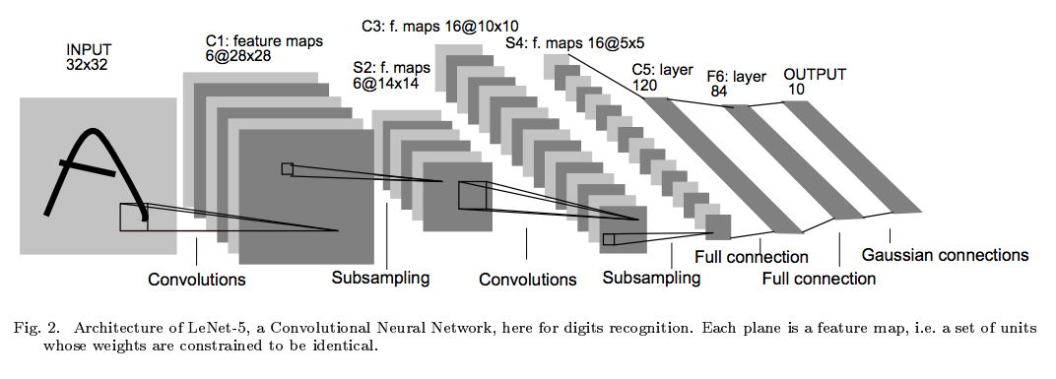

LeNet. Source: Yann Lecun.

You're now going to put together everything you've learned and implement the [**LeNet**](http://yann.lecun.com/exdb/publis/pdf/lecun-98.pdf) architecture using TensorFlow.

When you get to your next project, remember that LeNet can be a great starting point for your network architecture!

### Instructions:

1. Go to the LeNet with GPU workspace
2. Open the jupyter notebook LeNet-Lab.ipynb
3. Finish off the architecture implementation in the LeNet function. That's the only piece that's missing.

**Important:**Remember to **turn off** your GPU when not training.

### Preprocessing

An MNIST image is initially 784 features (1D). If the data is not normalized from [0, 255] to [0, 1], normalize it. We reshape this to (28, 28, 1) (3D), and pad the image with 0s such that the height and width are 32 (centers digit further). Thus, the input shape going into the first convolutional layer is 32x32x1.

### Specs

**Convolution layer 1**. The output shape should be 28x28x6.

**Activation 1**. Your choice of activation function.

**Pooling layer 1**. The output shape should be 14x14x6.

**Convolution layer 2**. The output shape should be 10x10x16.

**Activation 2**. Your choice of activation function.

**Pooling layer 2**. The output shape should be 5x5x16.

**Flatten layer**. Flatten the output shape of the final pooling layer such that it's 1D instead of 3D. The easiest way to do is by using tf.contrib.layers.flatten, which is already imported for you.

**Fully connected layer 1**. This should have **120 outputs**.

**Activation 3**. Your choice of activation function.

**Fully connected layer 2**. This should have **84 outputs**.

**Activation 4**. Your choice of activation function.

**Fully connected layer 3**. This should have **10 outputs**.

You'll return the result of the final fully connected layer from the LeNet function.

If implemented correctly you should see output similar to the following:

EPOCH 1 ...

Validation loss = 52.809

Validation accuracy = 0.864

EPOCH 2 ...

Validation loss = 24.749

Validation accuracy = 0.915

EPOCH 3 ...

Validation loss = 17.719

Validation accuracy = 0.930

EPOCH 4 ...

Validation loss = 12.188

Validation accuracy = 0.943

EPOCH 5 ...

Validation loss = 8.935

Validation accuracy = 0.954

EPOCH 6 ...

Validation loss = 7.674

Validation accuracy = 0.956

EPOCH 7 ...

Validation loss = 6.822

Validation accuracy = 0.956

EPOCH 8 ...

Validation loss = 5.451

Validation accuracy = 0.961

EPOCH 9 ...

Validation loss = 4.881

Validation accuracy = 0.964

EPOCH 10 ...

Validation loss = 4.623

Validation accuracy = 0.964

Test loss = 4.726

Test accuracy = 0.962

### Parameters Galore

As an additional fun exercise calculate the total number of parameters used by the network. Note, the convolutional layers use weight sharing!

### Additional Resources

There are many wonderful free resources that allow you to go into more depth around Convolutional Neural Networks. In this course, our goal is to give you just enough intuition to start applying this concept on real world problems so you have enough of an exposure to explore more on your own. We strongly encourage you to explore some of these resources more to reinforce your intuition and explore different ideas.

These are the resources we recommend in particular:

* Andrej Karpathy's [CS231n Stanford course](http://cs231n.github.io/) on Convolutional Neural Networks.
* Michael Nielsen's [free book](http://neuralnetworksanddeeplearning.com/) on Deep Learning.
* Goodfellow, Bengio, and Courville's more advanced [free book](http://deeplearningbook.org/) on Deep Learning.